­

Ferdy Pradana Putra

Aplikasi Perhitungan Menggunakan Bahasa Pemrograman Python dan Konsep Object Oriented Programing (OOP)

**Nama : Ferdy Pradana Putra**

**Nim : 200511032**

**Kelas : 20 C**

**Pemrograman Visual**

**Source Code**

1. **Persegi Panjang**

from tkinter import Frame, Label, Entry, Button, YES, BOTH, END, Tk, W

class FrmPersegi:

    def __init__(self, parent, title):

        self.parent = parent

        self.parent.geometry("400x400")

        self.parent.title(title)

        self.parent.protocol("WM_DELETE_WINDOW", self.onKeluar)

        self.aturKomponen()

    def aturKomponen(self):

        mainFrame = Frame(self.parent, bd=10)

        mainFrame.pack(fill=BOTH, expand=YES)

        # pasang Label

        Label(mainFrame, text='Panjang:').grid(row=0, column=0,

                                               sticky=W, padx=5, pady=5)

        Label(mainFrame, text="Lebar:").grid(row=1, column=0,

                                             sticky=W, padx=5, pady=5)

        Label(mainFrame, text="Luas:").grid(row=3, column=0,

                                            sticky=W, padx=5, pady=5)

        Label(mainFrame, text="Keliling:").grid(row=4, column=0,

                                                sticky=W, padx=5, pady=5)

        # pasang textbox

        self.txtPanjang = Entry(mainFrame)

        self.txtPanjang.grid(row=0, column=1, padx=5, pady=5)

        self.txtLebar = Entry(mainFrame)

        self.txtLebar.grid(row=1, column=1, padx=5, pady=5)

        self.txtLuas = Entry(mainFrame)

        self.txtLuas.grid(row=3, column=1, padx=5, pady=5)

        self.txtKeliling = Entry(mainFrame)

        self.txtKeliling.grid(row=4, column=1, padx=5, pady=5)

        # Pasang Button

        self.btnHitung = Button(mainFrame, text='Hitung',

                                command=self.onHitung)

        self.btnHitung.grid(row=2, column=1, padx=5, pady=5)

        # fungsi untuk menghitung luas dan keliling persegi panjang

    def onHitung(self, event=None):

        panjang = int(self.txtPanjang.get())

        lebar = int(self.txtLebar.get())

        perspanj = persegipanjang(panjang, lebar)

        luas = perspanj.luas()

        kel = perspanj.keliling()

        self.txtLuas.delete(0, END)

        self.txtLuas.insert(END, str(luas))

        self.txtKeliling.delete(0, END)

        self.txtKeliling.insert(END, str(kel))

    def onKeluar(self, event=None):

        # memberikan perintah menutup aplikasi

        self.parent.destroy()

class persegipanjang():

    # perhitungan dengan metode Pemrograman OOP

    def __init__(self, panjang, lebar):

        self.panjang = panjang

        self.lebar = lebar

    def luas(self):

        return self.panjang * self.lebar

    def keliling(self):

        return (2 * self.panjang) + (2 * self.lebar)

if __name__ == '__main__':

    root = Tk()

    aplikasi = FrmPersegi(root, "Program Luas dan Keliling Persegi Panjang")

    root.mainloop()

**Hasil Program Perhitungan Persegi Panjang**

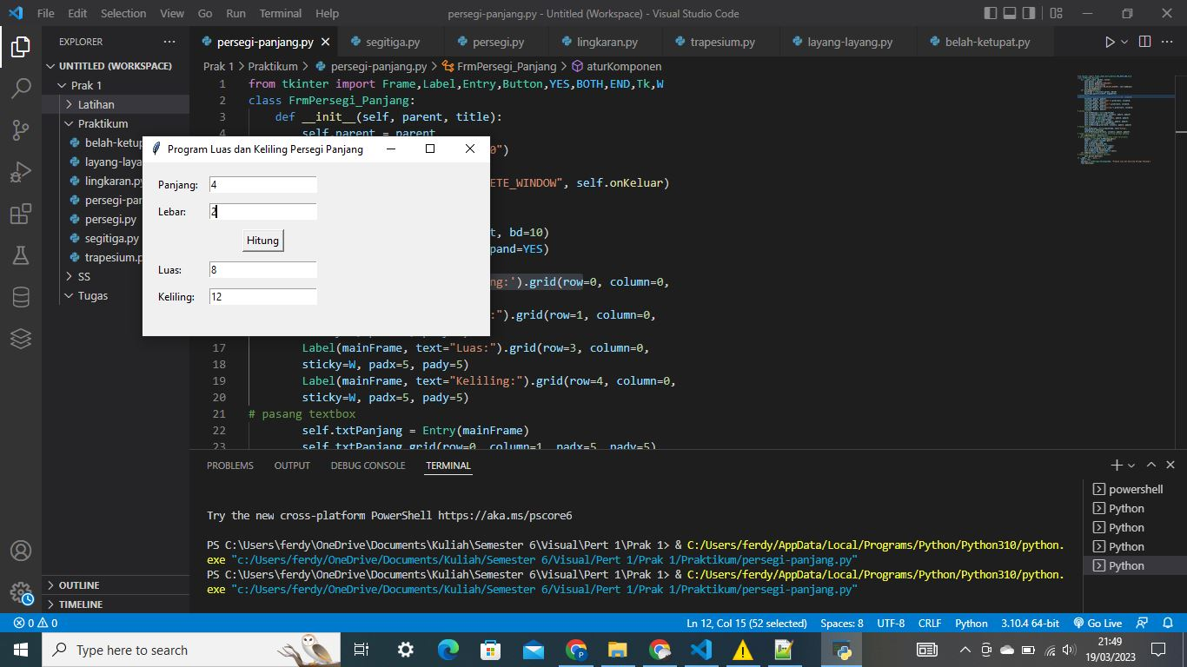

1. **Segitiga**

from tkinter import Frame, Label, Entry, Button, YES, BOTH, END, Tk, W

class FrmSegitiga:

    def __init__(self, parent, title):

        self.parent = parent

        self.parent.geometry("400x400")

        self.parent.title(title)

        self.parent.protocol("WM_DELETE_WINDOW", self.onKeluar)

        self.aturKomponen()

    def aturKomponen(self):

        mainFrame = Frame(self.parent, bd=10)

        mainFrame.pack(fill=BOTH, expand=YES)

        # pasang Label

        Label(mainFrame, text='Alas:').grid(row=0, column=0,

                                            sticky=W, padx=5, pady=5)

        Label(mainFrame, text="Tinggi:").grid(row=1, column=0,

                                              sticky=W, padx=5, pady=5)

        Label(mainFrame, text="Sisi a:").grid(row=2, column=0,

                                              sticky=W, padx=5, pady=5)

        Label(mainFrame, text="Sisi b:").grid(row=3, column=0,

                                              sticky=W, padx=5, pady=5)

        Label(mainFrame, text="Sisi c:").grid(row=4, column=0,

                                              sticky=W, padx=5, pady=5)

        Label(mainFrame, text="Luas:").grid(row=6, column=0,

                                            sticky=W, padx=5, pady=5)

        Label(mainFrame, text="Keliling:").grid(row=7, column=0,

                                                sticky=W, padx=5, pady=5)

        # pasang textbox

        self.txtAlas = Entry(mainFrame)

        self.txtAlas.grid(row=0, column=1, padx=5, pady=5)

        self.txtTinggi = Entry(mainFrame)

        self.txtTinggi.grid(row=1, column=1, padx=5, pady=5)

        self.txtSisia = Entry(mainFrame)

        self.txtSisia.grid(row=2, column=1, padx=5, pady=5)

        self.txtSisib = Entry(mainFrame)

        self.txtSisib.grid(row=3, column=1, padx=5, pady=5)

        self.txtSisic = Entry(mainFrame)

        self.txtSisic.grid(row=4, column=1, padx=5, pady=5)

        self.txtLuas = Entry(mainFrame)

        self.txtLuas.grid(row=6, column=1, padx=5, pady=5)

        self.txtKeliling = Entry(mainFrame)

        self.txtKeliling.grid(row=7, column=1, padx=5, pady=5)

        # Pasang Button

        self.btnHitung = Button(mainFrame, text='Hitung',

                                command=self.onHitung)

        self.btnHitung.grid(row=5, column=1, padx=5, pady=5)

        # fungsi untuk menghitung luas dan keliling persegi panjang

    def onHitung(self, event=None):

        # perhitungan dengan metode Pemrograman Terstruktur

        alas = int(self.txtAlas.get())

        tinggi = int(self.txtTinggi.get())

        sisia = int(self.txtSisia.get())

        sisib = int(self.txtSisib.get())

        sisic = int(self.txtSisic.get())

        segi3 = segitiga(alas, tinggi, sisia, sisib, sisic)

        luas = segi3.luas()

        kel = segi3.keliling()

        self.txtLuas.delete(0, END)

        self.txtLuas.insert(END, str(luas))

        self.txtKeliling.delete(0, END)

        self.txtKeliling.insert(END, str(kel))

    def onKeluar(self, event=None):

        # memberikan perintah menutup aplikasi

        self.parent.destroy()

class segitiga():

    # perhitungan dengan metode Pemrograman OOP

    def __init__(self, alas, tinggi, sisia, sisib, sisic):

        self.alas = alas

        self.tinggi = tinggi

        self.sisia = sisia

        self.sisib = sisib

        self.sisic = sisic

    def luas(self):

        return 0.5 * self.alas * self.tinggi

    def keliling(self):

        return self.sisia + self.sisib + self.sisic

if __name__ == '__main__':

    root = Tk()

    aplikasi = FrmSegitiga(root, "Program Luas dan Keliling Segitiga")

    root.mainloop()

**Hasil Program Perhitungan Segitiga**

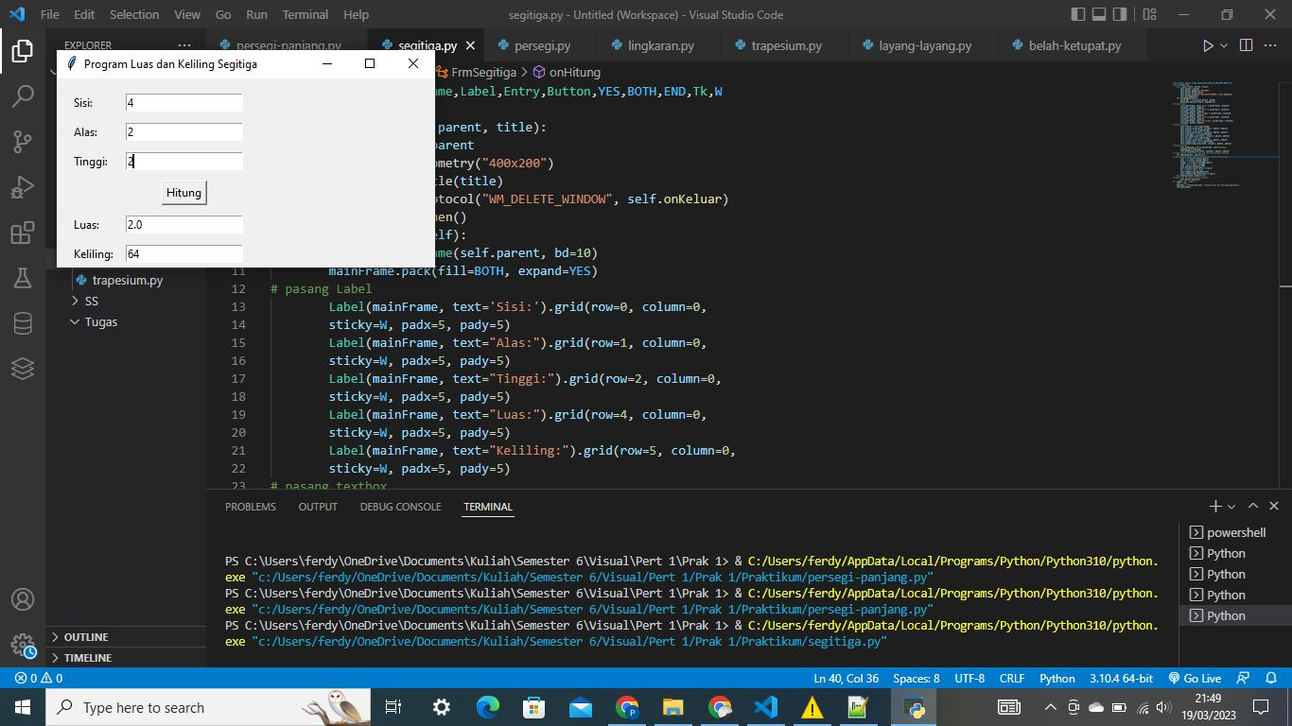

1. **Persegi / Bujur Sangkar**

from tkinter import Frame, Label, Entry, Button, YES, BOTH, END, Tk, W

class FrmPersegi:

    def __init__(self, parent, title):

        self.parent = parent

        self.parent.geometry("400x400")

        self.parent.title(title)

        self.parent.protocol("WM_DELETE_WINDOW", self.onKeluar)

        self.aturKomponen()

    def aturKomponen(self):

        mainFrame = Frame(self.parent, bd=10)

        mainFrame.pack(fill=BOTH, expand=YES)

        # pasang Label

        Label(mainFrame, text='Sisi :').grid(row=0, column=0,

                                             sticky=W, padx=5, pady=5)

        Label(mainFrame, text="Luas:").grid(row=2, column=0,

                                            sticky=W, padx=5, pady=5)

        Label(mainFrame, text="Keliling:").grid(row=3, column=0,

                                                sticky=W, padx=5, pady=5)

        # pasang textbox

        self.txtSisi = Entry(mainFrame)

        self.txtSisi.grid(row=0, column=1, padx=5, pady=5)

        self.txtLuas = Entry(mainFrame)

        self.txtLuas.grid(row=2, column=1, padx=5, pady=5)

        self.txtKeliling = Entry(mainFrame)

        self.txtKeliling.grid(row=3, column=1, padx=5, pady=5)

        # Pasang Button

        self.btnHitung = Button(mainFrame, text='Hitung',

                                command=self.onHitung)

        self.btnHitung.grid(row=1, column=1, padx=5, pady=5)

        # fungsi untuk menghitung luas dan keliling persegi panjang

    def onHitung(self, event=None):

        # perhitungan dengan metode Pemrograman Terstruktur

        sisi = int(self.txtSisi.get())

        perseg = persegi(sisi)

        luas = perseg.luas()

        kel = perseg.keliling()

        self.txtLuas.delete(0, END)

        self.txtLuas.insert(END, str(luas))

        self.txtKeliling.delete(0, END)

        self.txtKeliling.insert(END, str(kel))

    def onKeluar(self, event=None):

        # memberikan perintah menutup aplikasi

        self.parent.destroy()

class persegi():

    def __init__(self, sisi):

        self.sisi = sisi

    def luas(self):

        return self.sisi * self.sisi

    def keliling(self):

        return (4 * self.sisi)

if __name__ == '__main__':

    root = Tk()

    aplikasi = FrmPersegi(root, "Program Luas dan Keliling Persegi")

    root.mainloop()

**Hasil Program Perhitungan Persegi / Bujur Sangkar**

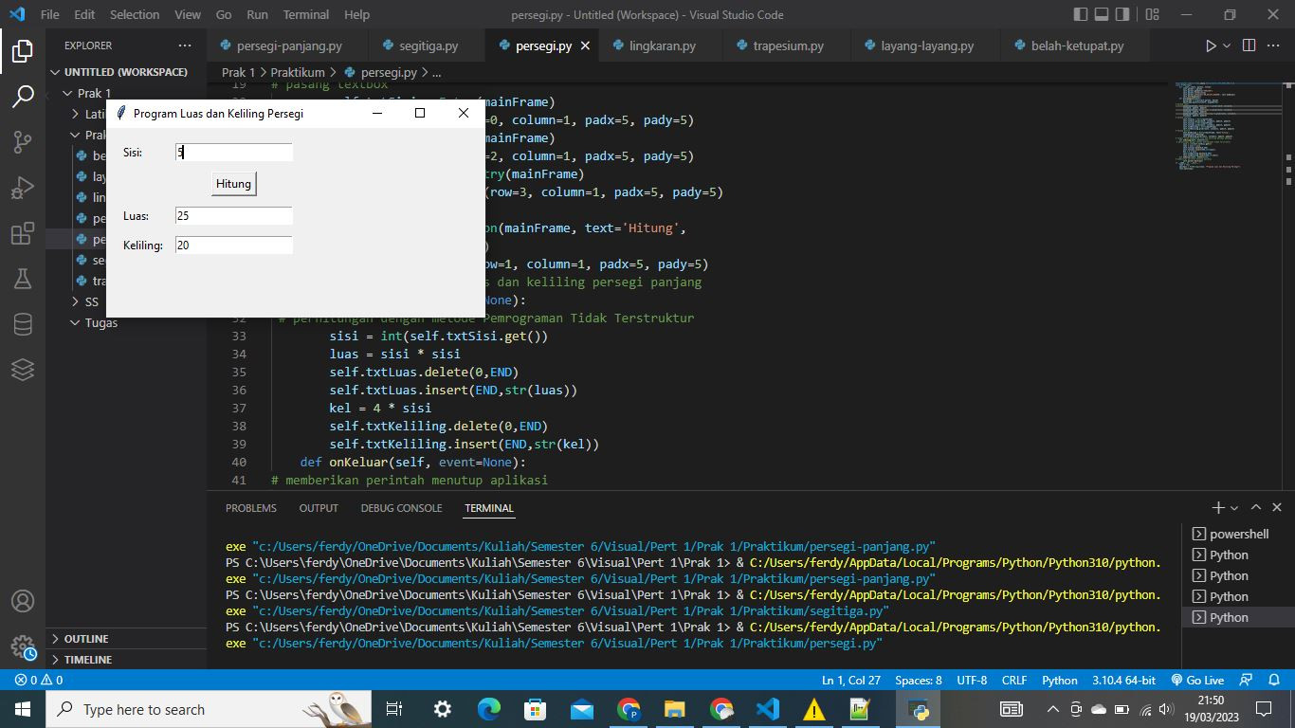

1. **Lingkaran**

from tkinter import Frame, Label, Entry, Button, YES, BOTH, END, Tk, W

class FrmLingkaran:

    def __init__(self, parent, title):

        self.parent = parent

        self.parent.geometry("400x400")

        self.parent.title(title)

        self.parent.protocol("WM_DELETE_WINDOW", self.onKeluar)

        self.aturKomponen()

    def aturKomponen(self):

        mainFrame = Frame(self.parent, bd=10)

        mainFrame.pack(fill=BOTH, expand=YES)

        # pasang Label

        Label(mainFrame, text='Jari Jari :').grid(row=0, column=0,

                                                  sticky=W, padx=5, pady=5)

        Label(mainFrame, text="Luas:").grid(row=2, column=0,

                                            sticky=W, padx=5, pady=5)

        Label(mainFrame, text="Keliling:").grid(row=3, column=0,

                                                sticky=W, padx=5, pady=5)

        # pasang textbox

        self.txtjari = Entry(mainFrame)

        self.txtjari.grid(row=0, column=1, padx=5, pady=5)

        self.txtLuas = Entry(mainFrame)

        self.txtLuas.grid(row=2, column=1, padx=5, pady=5)

        self.txtKeliling = Entry(mainFrame)

        self.txtKeliling.grid(row=3, column=1, padx=5, pady=5)

        # Pasang Button

        self.btnHitung = Button(mainFrame, text='Hitung',

                                command=self.onHitung)

        self.btnHitung.grid(row=1, column=1, padx=5, pady=5)

        # fungsi untuk menghitung luas dan keliling persegi panjang

    def onHitung(self, event=None):

        # perhitungan dengan metode Pemrograman Terstruktur

        jari = float(self.txtjari.get())

        bunder = lingkaran(jari)

        luas = bunder.luas()

        kel = bunder.keliling()

        self.txtLuas.delete(0, END)

        self.txtLuas.insert(END, str(luas))

        self.txtKeliling.delete(0, END)

        self.txtKeliling.insert(END, str(kel))

    def onKeluar(self, event=None):

        # memberikan perintah menutup aplikasi

        self.parent.destroy()

class lingkaran():

    # perhitungan dengan metode Pemrograman OOP

    def __init__(self, jari):

        self.jari = jari

    def luas(self):

        return 3.14 * (self.jari * self.jari)

    def keliling(self):

        return 2 * 3.14 * self.jari

if __name__ == '__main__':

    root = Tk()

    aplikasi = FrmLingkaran(root, "Program Luas dan Keliling Lingkaran")

    root.mainloop()

**Hasil Program Perhitungan Lingkaran**

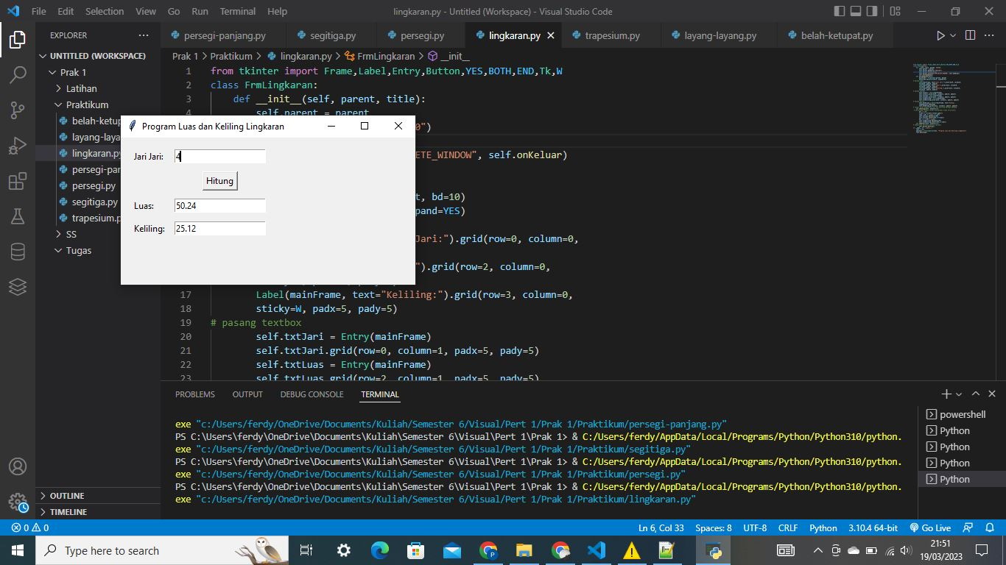

1. **Trapesium**

from tkinter import Frame, Label, Entry, Button, YES, BOTH, END, Tk, W

class FrmTrapesium:

    def __init__(self, parent, title):

        self.parent = parent

        self.parent.geometry("400x400")

        self.parent.title(title)

        self.parent.protocol("WM_DELETE_WINDOW", self.onKeluar)

        self.aturKomponen()

    def aturKomponen(self):

        mainFrame = Frame(self.parent, bd=10)

        mainFrame.pack(fill=BOTH, expand=YES)

        # pasang Label

        Label(mainFrame, text='Alas a :').grid(

            row=0, column=0, sticky=W, padx=5, pady=5)

        Label(mainFrame, text='Alas b :').grid(

            row=1, column=0, sticky=W, padx=5, pady=5)

        Label(mainFrame, text='Tinggi :').grid(

            row=2, column=0, sticky=W, padx=5, pady=5)

        Label(mainFrame, text='Sisi a:').grid(

            row=3, column=0, sticky=W, padx=5, pady=5)

        Label(mainFrame, text='Sisi b:').grid(

            row=4, column=0, sticky=W, padx=5, pady=5)

        Label(mainFrame, text='Sisi c:').grid(

            row=5, column=0, sticky=W, padx=5, pady=5)

        Label(mainFrame, text='Sisi d:').grid(

            row=6, column=0, sticky=W, padx=5, pady=5)

        Label(mainFrame, text="Luas :").grid(

            row=8, column=0, sticky=W, padx=5, pady=5)

        Label(mainFrame, text="Keliling :").grid(

            row=9, column=0, sticky=W, padx=5, pady=5)

        # pasang textbox

        self.txtalasa = Entry(mainFrame)

        self.txtalasa.grid(row=0, column=1, padx=5, pady=5)

        self.txtalasb = Entry(mainFrame)

        self.txtalasb.grid(row=1, column=1, padx=5, pady=5)

        self.txttinggi = Entry(mainFrame)

        self.txttinggi.grid(row=2, column=1, padx=5, pady=5)

        self.txtsisia = Entry(mainFrame)

        self.txtsisia.grid(row=3, column=1, padx=5, pady=5)

        self.txtsisib = Entry(mainFrame)

        self.txtsisib.grid(row=4, column=1, padx=5, pady=5)

        self.txtsisic = Entry(mainFrame)

        self.txtsisic.grid(row=5, column=1, padx=5, pady=5)

        self.txtsisid = Entry(mainFrame)

        self.txtsisid.grid(row=6, column=1, padx=5, pady=5)

        self.txtLuas = Entry(mainFrame)

        self.txtLuas.grid(row=8, column=1, padx=5, pady=5)

        self.txtKeliling = Entry(mainFrame)

        self.txtKeliling.grid(row=9, column=1, padx=5, pady=5)

        # Pasang Button

        self.btnHitung = Button(mainFrame, text='Hitung',

                                command=self.onHitung)

        self.btnHitung.grid(row=7, column=1, padx=5, pady=5)

        # fungsi untuk menghitung luas dan keliling persegi panjang

    def onHitung(self, event=None):

        # perhitungan dengan metode Pemrograman Terstruktur

        alasa = int(self.txtalasa.get())

        alasb = int(self.txtalasb.get())

        tinggi = int(self.txttinggi.get())

        sisia = int(self.txtsisia.get())

        sisib = int(self.txtsisib.get())

        sisic = int(self.txtsisic.get())

        sisid = int(self.txtsisid.get())

        trapes = trapesium(alasa, alasb, tinggi, sisia, sisib, sisic, sisid)

        luas = trapes.luas()

        kel = trapes.keliling()

        self.txtLuas.delete(0, END)

        self.txtLuas.insert(END, str(luas))

        self.txtKeliling.delete(0, END)

        self.txtKeliling.insert(END, str(kel))

    def onKeluar(self, event=None):

        # memberikan perintah menutup aplikasi

        self.parent.destroy()

class trapesium():

    # perhitungan dengan metode Pemrograman OOP

    def __init__(self, alasa, alasb, tinggi, sisia, sisib, sisic, sisid):

        self.alasa = alasa

        self.alasb = alasb

        self.tinggi = tinggi

        self.sisia = sisia

        self.sisib = sisib

        self.sisic = sisic

        self.sisid = sisid

    def luas(self):

        return 1/2 * (self.alasa + self.alasb) * self.tinggi

    def keliling(self):

        return self.sisia + self.sisib + self.sisic + self.sisid

if __name__ == '__main__':

    root = Tk()

    aplikasi = FrmTrapesium(root, "Program Luas dan Keliling Trapesium")

    root.mainloop()

**Hasil Program Perhitungan Trapeisum**

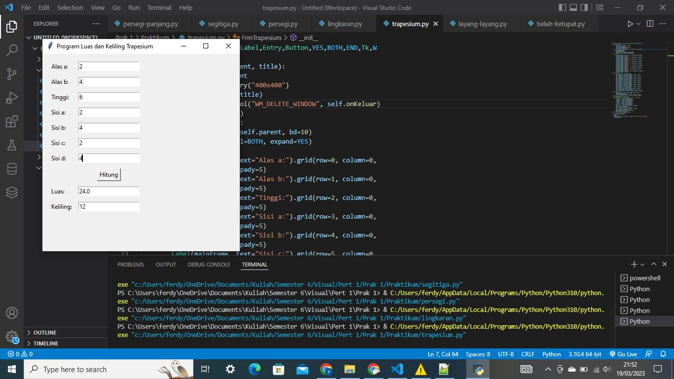

1. **Layang – Layang**

from tkinter import Frame, Label, Entry, Button, YES, BOTH, END, Tk, W

class FrmLayang:

    def __init__(self, parent, title):

        self.parent = parent

        self.parent.geometry("400x400")

        self.parent.title(title)

        self.parent.protocol("WM_DELETE_WINDOW", self.onKeluar)

        self.aturKomponen()

    def aturKomponen(self):

        mainFrame = Frame(self.parent, bd=10)

        mainFrame.pack(fill=BOTH, expand=YES)

        # pasang Label

        Label(mainFrame, text='Diagonal 1 :').grid(row=0, column=0,

                                                   sticky=W, padx=5, pady=5)

        Label(mainFrame, text='Diagonal 2 :').grid(row=1, column=0,

                                                   sticky=W, padx=5, pady=5)

        Label(mainFrame, text='Sisi Pendek Layang :').grid(row=2, column=0,

                                                           sticky=W, padx=5, pady=5)

        Label(mainFrame, text='Sisi Panjang Layang :').grid(row=3, column=0,

                                                            sticky=W, padx=5, pady=5)

        Label(mainFrame, text="Luas:").grid(row=5, column=0,

                                            sticky=W, padx=5, pady=5)

        Label(mainFrame, text="Keliling:").grid(row=6, column=0,

                                                sticky=W, padx=5, pady=5)

        # pasang textbox

        self.txtdiagonal1 = Entry(mainFrame)

        self.txtdiagonal1.grid(row=0, column=1, padx=5, pady=5)

        self.txtdiagonal2 = Entry(mainFrame)

        self.txtdiagonal2.grid(row=1, column=1, padx=5, pady=5)

        self.txtsisipen = Entry(mainFrame)

        self.txtsisipen.grid(row=2, column=1, padx=5, pady=5)

        self.txtsisipan = Entry(mainFrame)

        self.txtsisipan.grid(row=3, column=1, padx=5, pady=5)

        self.txtLuas = Entry(mainFrame)

        self.txtLuas.grid(row=5, column=1, padx=5, pady=5)

        self.txtKeliling = Entry(mainFrame)

        self.txtKeliling.grid(row=6, column=1, padx=5, pady=5)

        # Pasang Button

        self.btnHitung = Button(mainFrame, text='Hitung',

                                command=self.onHitung)

        self.btnHitung.grid(row=4, column=1, padx=5, pady=5)

        # fungsi untuk menghitung luas dan keliling persegi panjang

    def onHitung(self, event=None):

        # perhitungan dengan metode Pemrograman Terstruktur

        d1 = int(self.txtdiagonal1.get())

        d2 = int(self.txtdiagonal2.get())

        sipen = int(self.txtsisipen.get())

        sipan = int(self.txtsisipan.get())

        lyg = layang(d1, d2, sipen, sipan)

        luas = lyg.luas()

        kel = lyg.keliling()

        self.txtLuas.delete(0, END)

        self.txtLuas.insert(END, str(luas))

        self.txtKeliling.delete(0, END)

        self.txtKeliling.insert(END, str(kel))

    def onKeluar(self, event=None):

        # memberikan perintah menutup aplikasi

        self.parent.destroy()

class layang():

    # perhitungan dengan metode Pemrograman OOP

    def __init__(self, d1, d2, sipen, sipan):

        self.d1 = d1

        self.d2 = d2

        self.sipen = sipen

        self.sipan = sipan

    def luas(self):

        return 1/2 * (self.d1 * self.d2)

    def keliling(self):

        return 2 * (self.sipen * self.sipan)

if __name__ == '__main__':

    root = Tk()

    aplikasi = FrmLayang(root, "Program Luas dan Keliling Layang Layang")

    root.mainloop()

**Hasil Program Perhitungan Layang - Layang**

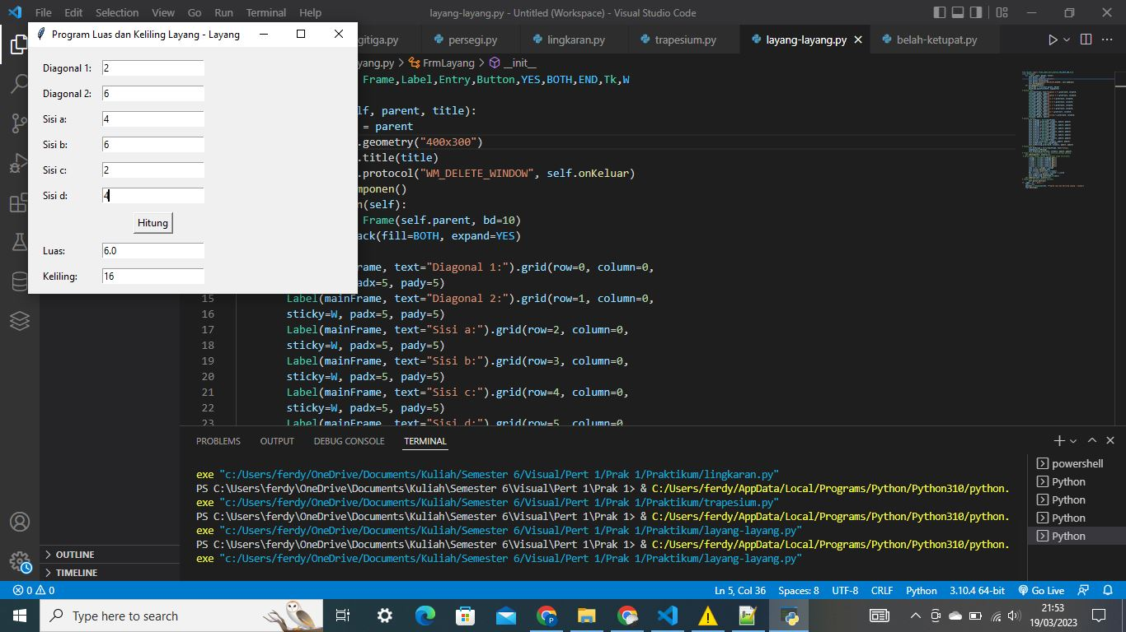

1. **Belah Ketupat**

from tkinter import Frame, Label, Entry, Button, YES, BOTH, END, Tk, W

class FrmBelahKetupat:

    def __init__(self, parent, title):

        self.parent = parent

        self.parent.geometry("400x400")

        self.parent.title(title)

        self.parent.protocol("WM_DELETE_WINDOW", self.onKeluar)

        self.aturKomponen()

    def aturKomponen(self):

        mainFrame = Frame(self.parent, bd=10)

        mainFrame.pack(fill=BOTH, expand=YES)

        # pasang Label

        Label(mainFrame, text='Diagonal 1 :').grid(

            row=0, column=0, sticky=W, padx=5, pady=5)

        Label(mainFrame, text='Diagonal 2 :').grid(

            row=1, column=0, sticky=W, padx=5, pady=5)

        Label(mainFrame, text='Sisi :').grid(

            row=2, column=0, sticky=W, padx=5, pady=5)

        Label(mainFrame, text="Luas :").grid(

            row=4, column=0, sticky=W, padx=5, pady=5)

        Label(mainFrame, text="Keliling :").grid(

            row=5, column=0, sticky=W, padx=5, pady=5)

        # pasang textbox

        self.txtdiagonal1 = Entry(mainFrame)

        self.txtdiagonal1.grid(row=0, column=1, padx=5, pady=5)

        self.txtdiagonal2 = Entry(mainFrame)

        self.txtdiagonal2.grid(row=1, column=1, padx=5, pady=5)

        self.txtsisi = Entry(mainFrame)

        self.txtsisi.grid(row=2, column=1, padx=5, pady=5)

        self.txtLuas = Entry(mainFrame)

        self.txtLuas.grid(row=4, column=1, padx=5, pady=5)

        self.txtKeliling = Entry(mainFrame)

        self.txtKeliling.grid(row=5, column=1, padx=5, pady=5)

        # Pasang Button

        self.btnHitung = Button(mainFrame, text='Hitung',

                                command=self.onHitung)

        self.btnHitung.grid(row=3, column=1, padx=5, pady=5)

        # fungsi untuk menghitung luas dan keliling persegi panjang

    def onHitung(self, event=None):

        # perhitungan dengan metode Pemrograman Terstruktur

        d1 = int(self.txtdiagonal1.get())

        d2 = int(self.txtdiagonal2.get())

        sisi = int(self.txtsisi.get())

        belah = belahketupat(d1, d2, sisi)

        luas = belah.luas()

        kel = belah.keliling()

        self.txtLuas.delete(0, END)

        self.txtLuas.insert(END, str(luas))

        self.txtKeliling.delete(0, END)

        self.txtKeliling.insert(END, str(kel))

    def onKeluar(self, event=None):

        # memberikan perintah menutup aplikasi

        self.parent.destroy()

class belahketupat():

    # perhitungan dengan metode Pemrograman OOP

    def __init__(self, d1, d2, sisi):

        self.d1 = d1

        self.d2 = d2

        self.sisi = sisi

    def luas(self):

        return 1/2 * (self.d1 * self.d2)

    def keliling(self):

        return 4 * self.sisi

if __name__ == '__main__':

    root = Tk()

    aplikasi = FrmBelahKetupat(root, "Program Luas dan Keliling Belah Ketupat")

    root.mainloop()

**Hasil Program Perhitungan Belah Ketupat**

